Morning Checklist

* Hat
* Jumper
* Lunchbox
* Drink bottle
* School bag

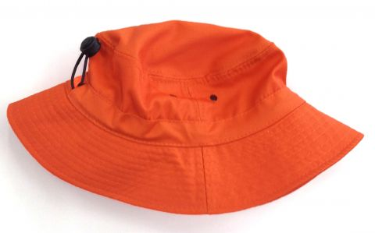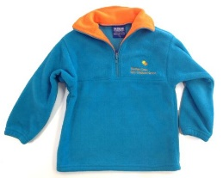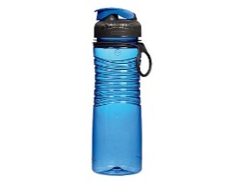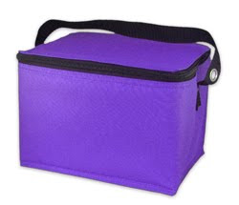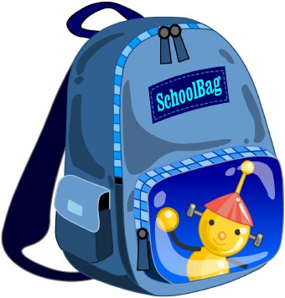

Morning Checklist

* Hat
* Jumper
* Lunchbox
* Drink bottle
* School bag

